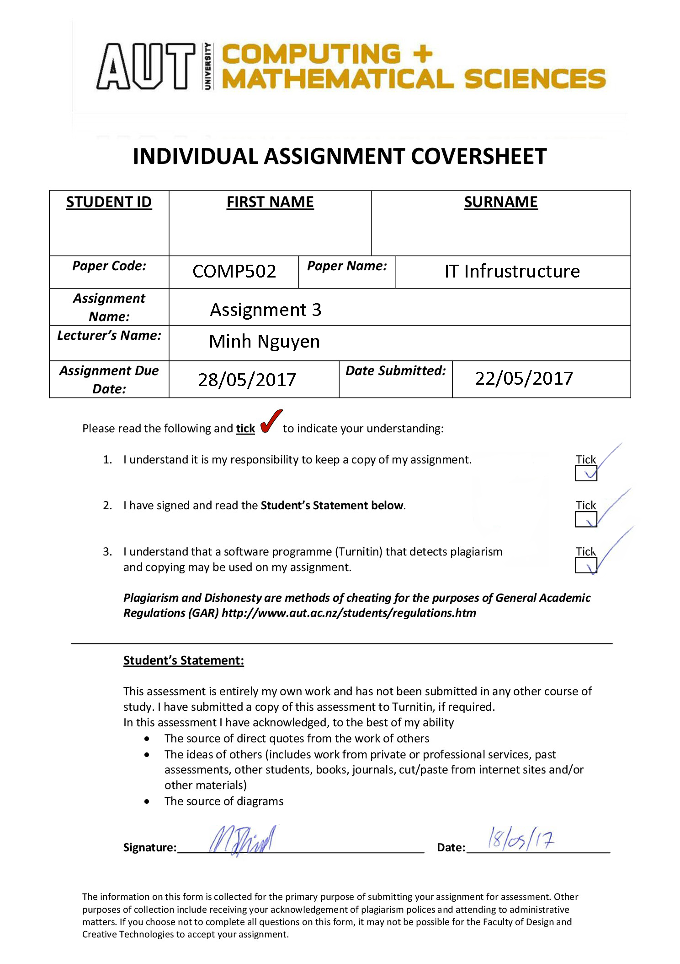

Question 1:

* The two Linux operating systems I used where *Lucid Puppy* and *Arch Linux*.
* 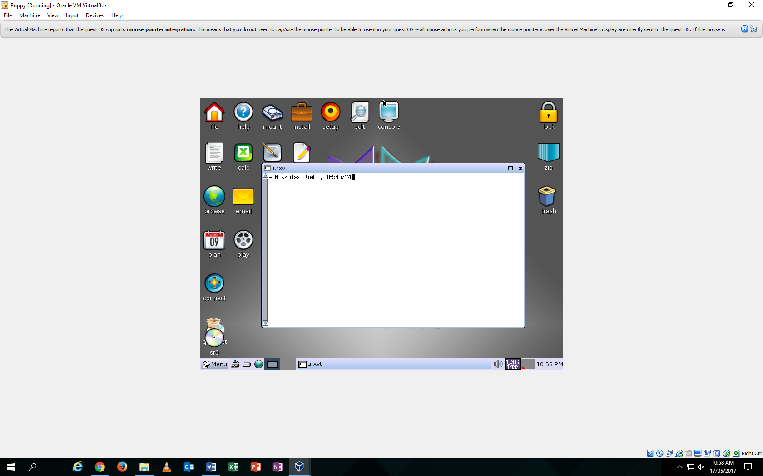Lucid Puppy with my name and ID number: <https://i.imgur.com/kpyKHS5.png>
* 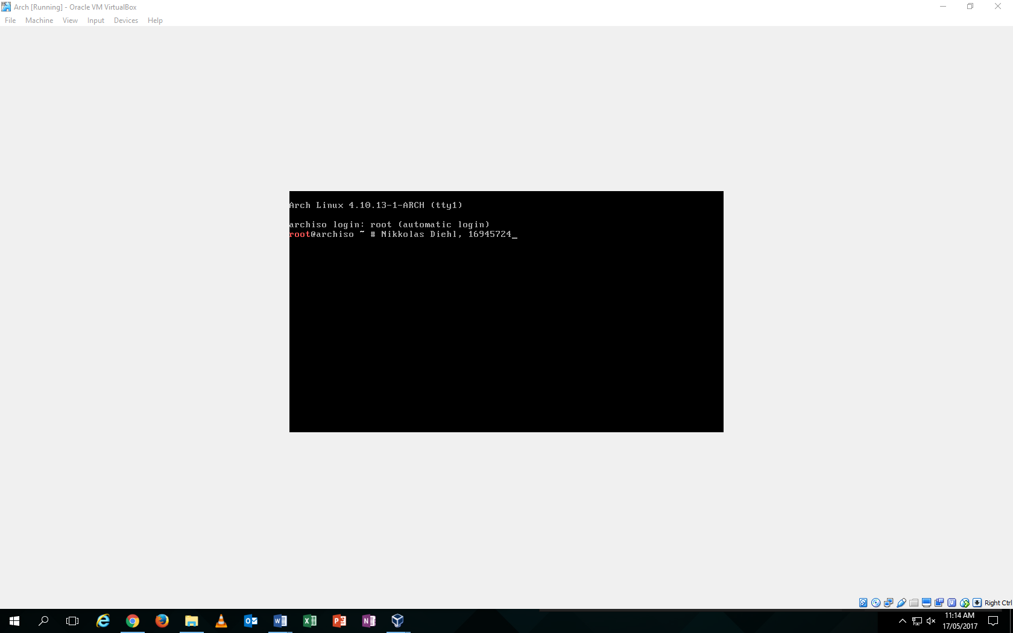Arch Linux with my name and ID number: <https://i.imgur.com/75ltWb9.png>
* Lucid Puppy is an extremely basic operating system that mostly uses the CLI to control its abilities. However, it is built with an entire GUI similar to that of Apple in the first stages. The GUI has all the necessary thing needed to do normal computer work. Its command line (which is what you would mostly work with) is white and looks like a note pad. Lucid Puppy would be useful to an extent with every day workers.
* Arch Linux is a different operating system altogether and works primarily on its CLI. It has no GUI at all and simply runs of the users input. This operation system, unlike Lucid Puppy, would be more efficient for server work and data storage. Being able to directly and instantly access the CLI and the operating systems abilities is perfect for servers without the busy mess of a GUI.
* I much preferred the Arch Lunix because of its simplistic and up front build. It’s extremely easy to use and has no GUI problems. Lucid puppy struggles a lot with lag and has a lot of extra, inefficient junk that is not needed in most, everyday server work. Because of my limited experience with Lunix, I have found the direct console access from a simplistic operating system like Arch to work best for me.

Question 2:

* Part C – Show the Absolute path of your **Home directory:**

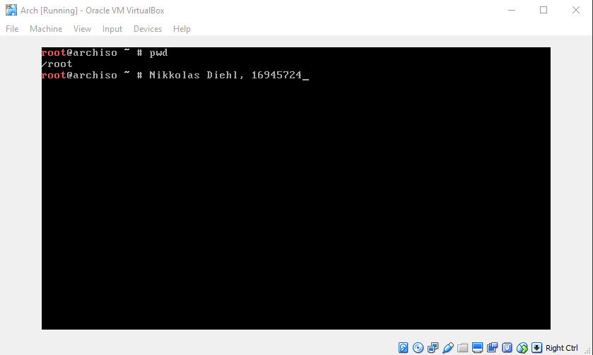

* Part D – Create a new directory inside your home directory and name it **FTIT-hw1**

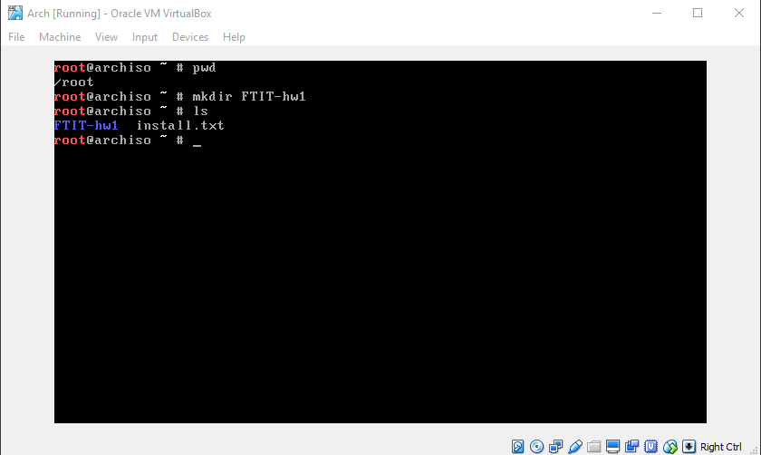

I made the directory of FTIT-hw1 and listed out all directories to prove it’s creation.

* Part E – Without moving into the directory I just created, I will create two new directories using **one command** inside of the **FTIT-hw1** directory, and name them **assign1** and **assign2**

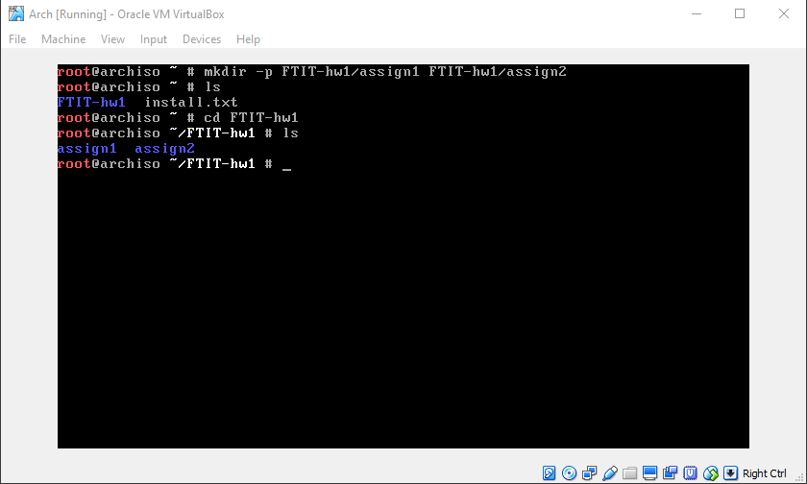

After the code above, after already creating the FTIT-hw1 directory, I then created, using the parent argument, two directories FROM the home directory within the FTIT-hw1 directory. I then listed from the home drive to check that FTIT-hw1 was there, and then I went into the FTIT-hw1 directory and listed the directories inside that to prove the creation of the two different and separate directories.

* Part F – Navigate to the FTIT-hw1 directory:

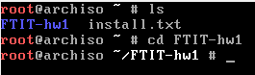

* Part G – Create two new files without opening any text editor using **one command** inside of the **FTIT-hw1** directory, and name then **file1** and **file2:**

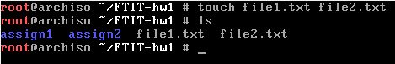

Continuing on from the previous section, being already inside the FTIT-hw1 directory, I used the touch command to create two new files called **file1** and **file2**. I then used a quick list command to prove their existence.

* Part H – Display the contents of my working directory:



The same command I used in the previous section displays the inside of my directory (named **FTIT-hw1**)

* Part I – Delete the directory **assign2**

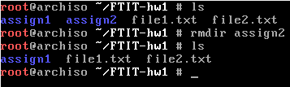

I listed out the contents of FTIT-hw1 to show a before and after scenario. I then deleted the directory named assign2 using the rmdir command. I then listed the contents of FTIT-hw1 again to prove it deletion of assign.

* Part J – Display the contents again of the directory **FTIT-hw1**, this time using a long-listed format:

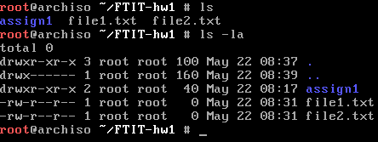

I performed a quick normal list to get the contents of directory FTIT-hw1 before using ls -la which listed all hidden files, and normal files with all the information and data pertaining to them such as creation date and so on.

Question 3:

* Part A and B – Create a new directory in home directory and create a directory inside that called assign3:

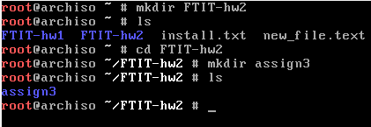

For this question, and for showmanship, I created the FTIT-hw2 directory, then listed off the contents of the home directory (the new_file.text was a test, ignore it). I then went into FTIT-hw2 using the cd command. Then I created a new directory called assign3, and then listed the contents of FTIT-hw2 to prove assign3 existed.

* Part C – Create 7 new files using one command inside FTIT-hw2 named given names.

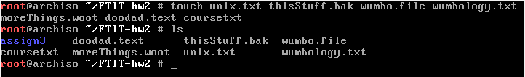

I created the 7 files named unix.txt, thisStuff.bak, wumbo.file, wumbology.txt, moreThings.woot, doodad.txt and coursetxt and listed them to show that they where there.

* Part D – List all the files:



All the files and directories inside FTIT-hw2 listed

* Part E – Display/list all files ending with .txt only with one command.



Listing the files/directories ending in .txt using a list with pointers.

* Part F – Display/list all the files in the current file that start with **u** and end with **t** using one command:



I used the combination of finding files that start with **u** and characters that end with **t** and put them together. * means every character. So, it finds any file or directory that begins with **u**, has ANY character after **u** and then stops looking for files that end with something other than **t**.

* Part G – Copy all the files containing “**wumbo**” to the directory **assign3** using one command:

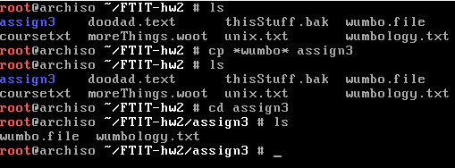

In this code, I started with a quick list to show everything inside FTIT-hw2. Then I used the copy command cp, that copied anything that contained wumbo or was inclusive of wumbo (*wumbo*) to assign3. Then I listed again, then used cd to get into assign3 directory and listed again. It then shows proof of all files containing wumbo being copied into assign3 directory.

* Part H - Display list of files and directories of assign3 without navigating there:



Here, I am inside the FTIT-hw2 directory as the screenshot shows. From here, I use the ls command, but I search inside the assign3 directory. From here, I can see that from the FTIT-hw2 directory, inside the assign3 directory, is two files. They are files that *contain* the word wumbo that where copied from Part G.